狮城漫步
A Stroll in the Lion City
为华乐团而作
for Chinese Orchestra

谢湘铭
Xie Xiangming

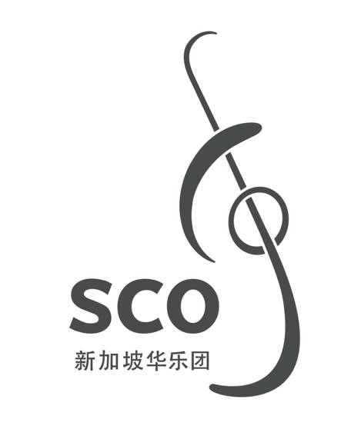

00/000
狮城漫步
A Stroll in the Lion City
为华乐团而作
for Chinese Orchestra

谢湘铭
Xie Xiangming
(2011)
11'
狮城漫步
A Stroll in the Lion City

ISMN

Copyright © Singapore Chinese Orchestra Co. Ltd. All rights reserved.

版权所有, 未经许可, 不得以任何形式印刷、复制、扫描或发行。
Unauthorised printing, reproduction, scanning or distribution is strictly prohibited
without the express permission of the copyright holder.

印刷于新加坡。
Printed in Singapore.

新加坡华乐团有限公司
珊顿道7号
新加坡大会堂
新加坡邮区 068810

Singapore Chinese Orchestra Co. Ltd.
7 Shenton Way
Singapore Conference Hall
Singapore 068810

网站 Website: www.sco.com.sg
电邮 Email: aa@sco.com.sg
电话 Telephone: (65) 6557 4026
传真 Fax: (65) 6557 2756
传Biography
谢湘铭1974年出生于福建漳州，祖籍龙岩客家。自幼随父学习扬琴、小提琴、钢琴和作曲。1991年考入上海音乐学院作曲指挥系，师从王建中教授学习作曲。毕业后曾任上海音乐学院附中作曲科教师，现为活跃于多种领域音乐创作的自由音乐人。创作体裁广泛，作有交响乐、室内乐、合唱、音乐剧等多种体裁的音乐，风格类型多样，现代、古典、流行、民间、宗教、电子等风格均有涉及，并在各种体裁和风格中均体现鲜明的个人特征。

Xie Xiangming was born in Zhangzhou, Fujian Province in 1974, of Hakka Longyuan descent. He learnt to compose and to play the dulcimer, violin and piano from his father during his childhood, and was admitted to the Shanghai Conservatory of Music Composition and Conducting Department in 1991 to study composition under the tutelage of Professor Wang Jianzhong. He teaches in the Composition Department of Middle School Affiliated to Shanghai Conservatory of music and is actively engaged in various fields of composition. His works include symphonies, chamber music, choral music and musicals etc. His distinctive personal style is expressed through diverse genres such as modern, classical, pop, folk, religious and electronic music.
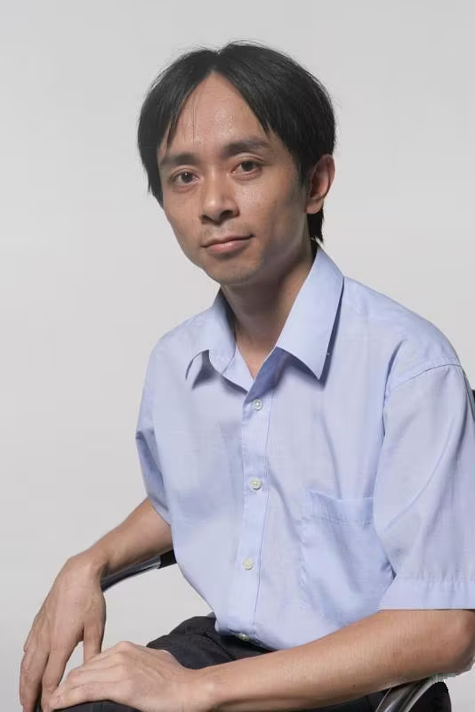

乐曲介绍Synopsis
新加坡多元种族的文化给作曲家留下了深刻的印象，尤其是带着浓郁中国南部文化的现代化大都市气息，对于出生在福建南部但成长于非福建文化大都市的上海作曲家有着强烈的吸引力。乐曲着重描写朝气蓬勃的现代都市气息和精致典雅、丰富多姿的南洋风情，并融合中华传统文化由景生情、情景交融的意境。作曲技法上不拘一格地使用中国南部音乐元素与西洋现代、古典、浪漫等多种手法相结合, 也尝试借此来体现新加坡的多样化以及内在精神。
此作品荣获2011年新加坡国际华乐作曲大 赛创作第一奖。

Singapore's multi-racial culture left a deep impression on the composer. Born in the southern part of Fujian province but brought up in the Shanghai metropolis, the composer was strongly attracted and took a special liking to Singapore's rich flavour of a modern metropolis with an eastern China's cultural atmosphere. The composition emphasises the vibrant, elegant and bustling city life and describes the charms of Nanyang. It depicts scenes of its rich and diverse sentiments, integrated with aspects of traditional Chinese culture. The composer adopts an array of composition techniques with a combination of elements from various influences, including the southern Chinese, western modern, classical and romantic music to reflect the diversity and inner spirit of Singapore.
This piece won the First Prize at the Singapore International Competition for Chinese Orchestral Composition 2011.

编制Instrumentation
梆笛 I, II Bangdi I, II
曲笛 Qudi
新笛 I, II Xindi I, II
高音笙 I, II Gaoyin Sheng I, II
中音笙 Zhongyin Sheng
低音笙 Diyin Sheng
加键高音唢呐I, II Keyed Gaoyin Suona I, II
中音唢吶 Zhongyin Suona
次中音唢吶 Cizhongyin Suona
低音唢吶 Diyin Suona

扬琴 Yangqin (2)*
柳琴Liuqin (2)
琵琶Pipa (4)
中阮Zhongruan (4)
大阮Daruan (2)
古筝Guzheng (2)

定音鼓 Timpani
4 打击乐 Percussion
I: 大军鼓 Bass Drum, 板鼓 Bangu
II: 吊镲 Suspended Cymbal, 碰铃 Pengling, 低音木鱼 Low Woodblock
III: 小军鼓 Snare Drum, 铃鼓 Tambourine, 钟琴 Glockenspiel, 小钹 Xiaobo, 小堂鼓 Xiaotanggu
IV: 乐鞭Whip, 中钹 Zhongbo, 小钹 Xiaoluo, 大钹 Daluo, 西洋镲 Cymbals

高胡 Gaohu
二胡 Erhu I
二胡 Erhu II
中胡 Zhonghu
大提琴 Violoncello
低音提琴 Contrabass

* 括号内的数字为推荐演奏人数 。Numbers in parenthesis indicate recommended amount of players.

